The Post Office 7 Middle Street, Elton, Peterborough, PE8 6RA
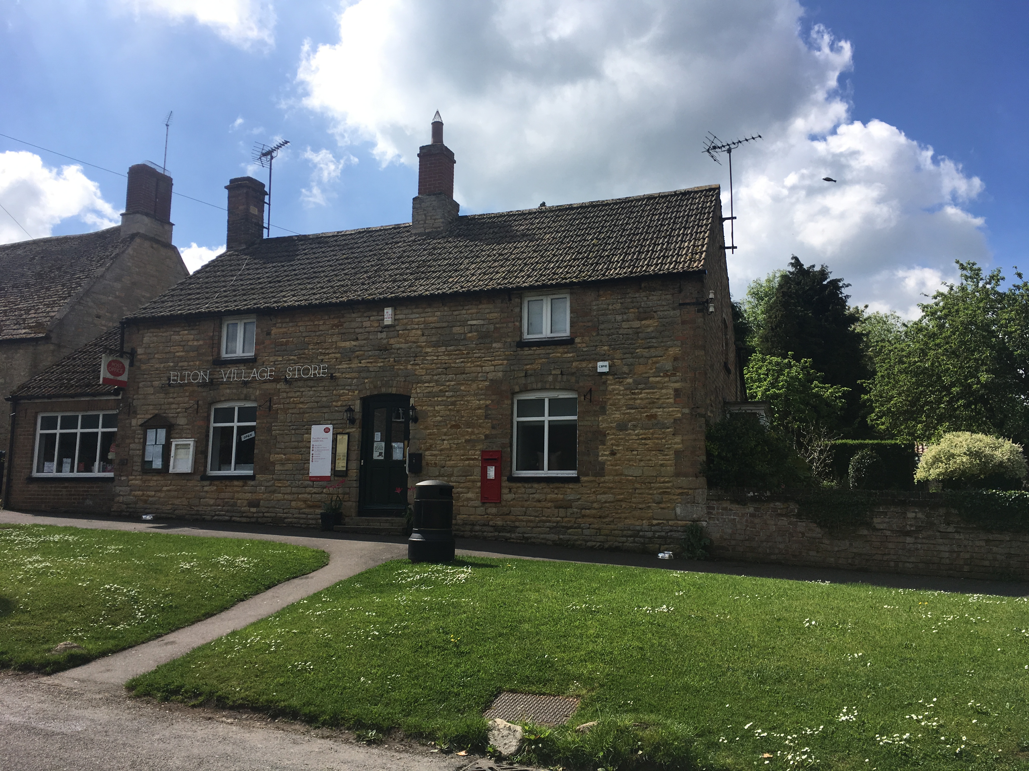
Elton Estate is offering to let this detached Post Office and village store commercial property with adjoining 2 bed residential property situated in the main street of Elton village. The property has traded as the village post office and stores for many years selling a range of goods and newspapers but also offers the potential for a range of new business uses alongside the post office and stores. The Post Office has indicated that the Post Office local business can continue in the property with a suitably qualified tenant without any ingoing capital payment and the stores has strong support within the local community
In brief, the property provides the following accommodation:

Ground Floor - Commercial
Entrance Lobby
Retail Area
15’9” x 14’5” (4.8m x 4.4m) and 17’1” x 10’10” (5.2m x 3.3m), description photo

Ground Floor – Residential

Porch

Hall

Bathroom

8’6” x 5’11” (2.6m x 1.8m)

Kitchen

15’5” x 9’2” (4.7m x 2.8m)

Lounge

15’5” x 10’2” (4.7m x 3.1m)

Stairs

First Floor
Landing / walkthrough bedroom
14’5 2 x 9’2” (404m x 2.8m)
Bedroom 1
17’5” x 15’9” (5.3m x 4.8m)

Bedroom 2
18’6” x 8’2” (5.7m x 2.5m)

Outside
Outbuildings
Substantial garage and Outbuilding used as storage for the business to side an rear of property.
Dimensions - photo
Outside
Rear courtyard and to the side of the property a garden of good size mainly to lawn
photo

General Information
Viewing
All appointments should be made through the Elton Estate Office 01832 280 223. To avoid disappointment, particularly if coming from far away, we would recommend that interested parties contact the Estate Office to discuss the property before arranging viewings.
Tenure
The property will be offered to let, unfurnished, on an business lease for a length to be agreed.
Services
Mains electricity, water and drainage.
Oil fired central heating

Local Authority

Huntingdonshire District Council Tel: 01480 388388

Important Notice
1. These particulars do not form part of any offer or contract and must not be relied upon as statements or representations of fact.
2. Any areas, measurements or distances are for guidance only and are not necessarily comprehensive. No services, equipment or facilities have been tested. Tenants must satisfy themselves by inspection or otherwise.

Contact
Elton Estate Office
Elton Hall
Elton
Peterborough
PE8 6SH
Tel: 01832 280223
Fax: 01832 280584
email: office@eltonhall.com
VIEWING STRICTLY BY APPOINTMENT ONLY


