

**Unit 7 THE OLD DAIRY**

Elton, Peterborough PE8 6SQ

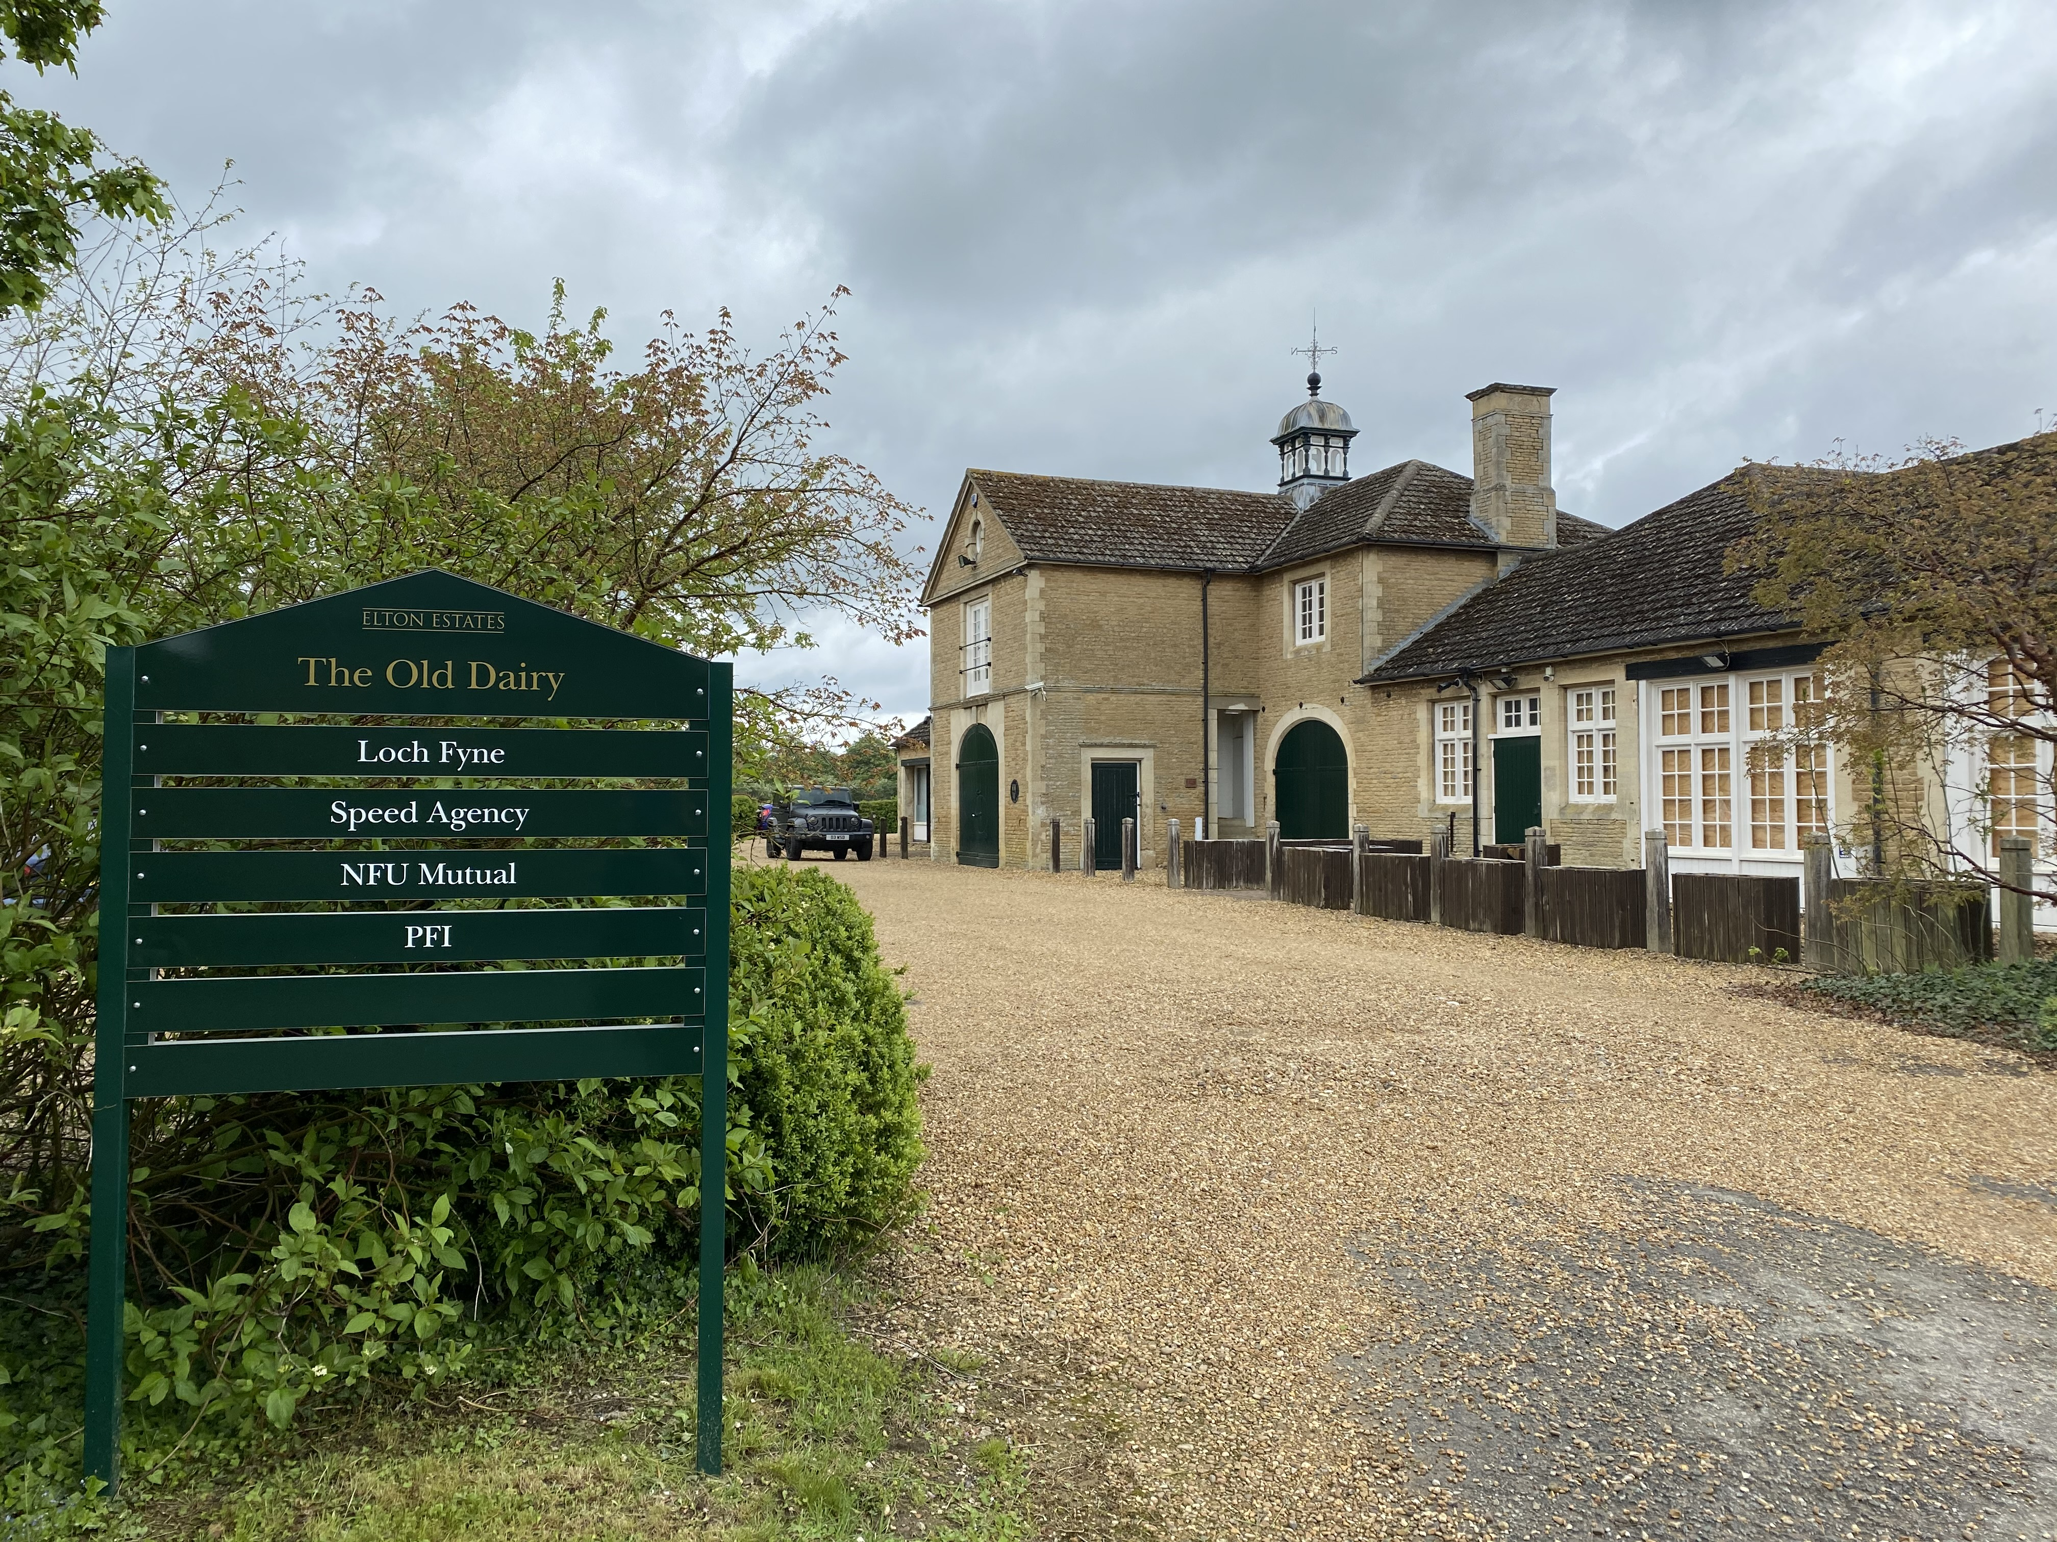

**Available Now, Unit 7 The Old Dairy**

* Unit 7 is within a converted dairy building, dating from the 19th Century, and is suitable for a range of commercial uses including office and retail.
* The unit is 1,033 sq ft GIA (gross internal area) and 920 sq ft NIA (net internal area)
* Rent is £10,000 per annum exclusive of VAT and service charge.
* Easy access to the A605 and A1(M)
* Very generous on-site car parking and direct car park access.
* Rural location
* The unit is located to the front of the building, on the first floor (**please note the unit is only accessible via a staircase)**



**Location**

The Old Dairy is located on the edge of Elton Village, just off the A605, approximately 6 miles west of Peterborough and 5 miles east of Oundle. There are excellent links to the A1(M) at Peterborough and the A14 at Thrapston. Peterborough Train Station has regular direct train services to a large network of stations, including London Kings Cross (50 mins) and Birmingham.

Elton Village benefits from a shop, garden centre with café and two pubs, both serving food. The Old Dairy currently comprises office units and a hairdresser. In neighbouring Warmington Village there is a post office/shop and a pub.

*Indicative floor plan, not to scale.*



|  |  |
| --- | --- |
|  |  |

**Service Charge**Service charge is payable in respect of the maintenance of the common areas and the exterior of the building.

**Insurance Charge**A proportion of the total building

**Terms**The premises are available to let on a new lease on terms to be agreed.

**Business Rates**Unit 7 qualifies for business rate relief, subject to standard exemptions. Interested parties are advised to contact the Council to confirm the Rates Payable.

**Legal Costs**Each party to bear their own legal costs in the transaction.

**Important Notice**Any areas, measurements or distances are for guidance only and are not necessarily comprehensive.

|  |  |
| --- | --- |
|  | **Viewing**  Viewing is strictly by appointment only and arrangements may be made through:  Elton Estate Office, Elton Hall, Elton, Peterborough, PE8 6SH.  **Telephone 01832 280223**  Email [office@eltonhall.com](mailto:office@eltonhall.com) |

**IMPORTANT NOTICE**

These particulars are intended as a guide and must not be relied upon as statements of fact. Your attention is drawn to the important notice below. The particulars are intended to give fair and substantially correct overall description for the guidance of intending tenants and do not constitute, nor constitute part of, an offer or contract. No responsibility is assumed for the accuracy of individual items. Prospective tenants ought to seek their own professional advice. All descriptions, dimensions, area, reference to condition and necessary permission for use and occupation and their details are given in good faith and are believed to be correct, but any intending tenants should not rely on them as statements or representations of fact but must satisfy themselves by inspection or otherwise as to the accuracy of each of them.

No person in the employment of Elton Estates has any authority to make or give any representations or warranty whatever in relation to this property or these particulars nor enter into any contract relating to the property on behalf of the landlord. No responsibility can be accepted for any expenses incurred by intending tenants in inspecting properties, which have been sold, let or withdrawn. It should not be assumed that the property has all the necessary planning, building regulation or other consents. Where any reference is made to planning permissions or potential uses such information is given in good faith.

The information in these particulars is given without responsibility on the part of the agents or their clients. These particulars do not form any part of an offer of a contract and neither the agents nor their employees have any authority to make or give any representations or warranty whatever in relation to this property.